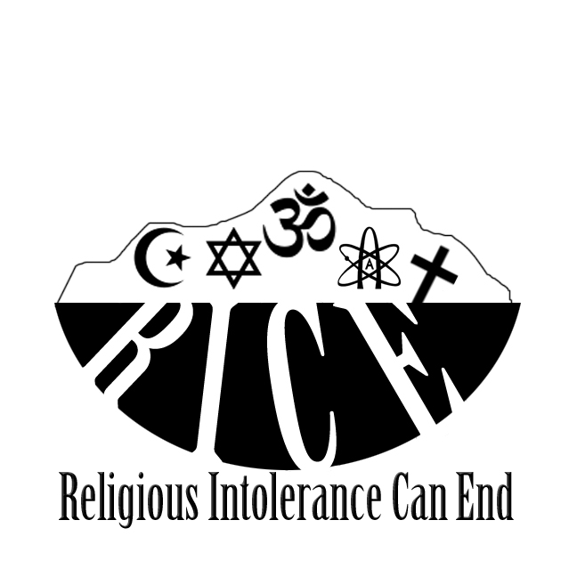
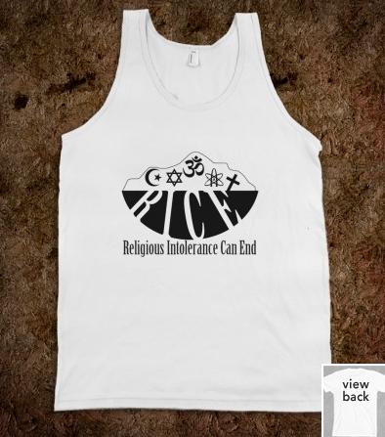
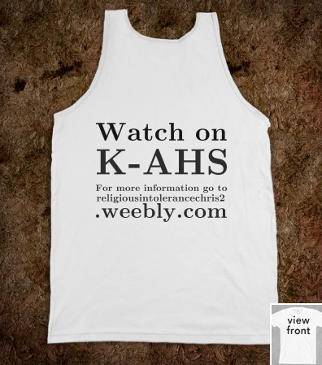
I ordered one of these t shirts and we’re each going to wear it once, on the days that our videos are aired on K-AHS.

We decided on the acronym R.I.C.E. and I developed the logo from there. The use of a rice bowl and the symbols in the bowl, indicate a world (the bowl) where are religions and people can coexist (the symbols as rice).
http://www.youtube.com/watch?v=Q3Z2TNjpGQ0&feature=youtu.be
This is the link to my video interview with Neel Agarwal, this video series our group created is both our take action and our advocacy. Our other advocacy projects were built around the videos, to get people’s attention when the videos begin to air on K-AHS. I also created a facebook page for our peers to like that will give them instant updates and reminders for the airing of the videos. After one video airs were going to post it on the facebook page, so there is a max amount of viewer ship. https://www.facebook.com/RiceReligiousIntoleranceCanEnd

