 Keep

Austin

Green!

A Guide to reducing your carbon footprint and living a greener life



April 2013

Made by Alana Hughes

Table of Contents

The Issue:

1. The Global Issue……………………………………………3
2. Our Austin Issue…………………………………………..4

What You Can Do To Help:

1. Cut Household Emissions…………………………….5
2. Reduce, Reuse, Recycle………………………………6
3. Grow Green…………………………………………………….7
4. Eat Green……………………………………………………….8
5. Drive Green……………………………………………………9

Take Action…………………………………………………………………….10

How you can Take Action...............................................11

Works Cited…………………………………………………………………..12

The Global Issue

The Earth’s average temperature has increased by 1.4 degrees Fahrenheit over the past century and is projected to raise faster and even more over the next hundred years. So who’s to blame? Humans. We are largely responsible for recent climate change in our nation. For years, large amounts of carbon dioxide and other greenhouse gasses have been released into the atmosphere because of human activities. The result is the greenhouse gas effect, which is the action of greenhouse gasses trapping energy in the atmosphere and causing it warm (EPA). This changes the Earth’s climate and results in negative effects on health and ecosystems.

Today, as cities become larger and the world continues to become more and more industrialized, humans are putting more greenhouse gasses into the atmosphere. While this is happening though, some people are choosing to ignore the issue, claiming that climate change is not caused by human activities.

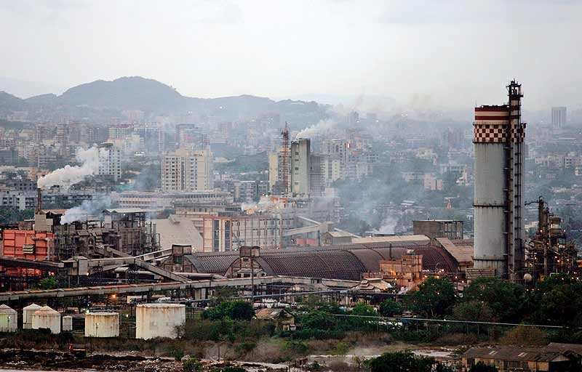The truth is, climate change effects everyone and in places like Mumbai, India where an individual’s carbon emissions are twice the size of the national average, people have little opportunity or support from their government to reduce their carbon footprint. In places like this, individuals lack knowledge on the importance of reducing their carbon emissions resulting in a city whose inhabitants are prone to health problems and lack a stable environment (Rebello, Snehal).

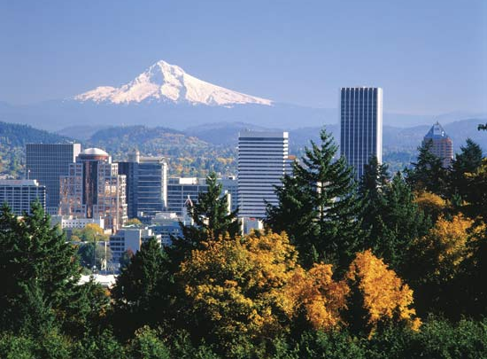While there are cities like Mumbai, there are also cities such as Reykjavik, Iceland and Portland, Oregon who are recognized as the top 2 greenest cities (Green Cities). While it is true that these cities wouldn’t be the way they are without support from local leaders, they also could not have achieved this distinction without the support of the individuals living in those cities.

All it takes is support from individuals as well as knowledge on the issue to make a big and important difference. It is time that everyone realized that the choices we each make today could make a difference and reduce the impact of climate change in the future.

Our Austin Issue

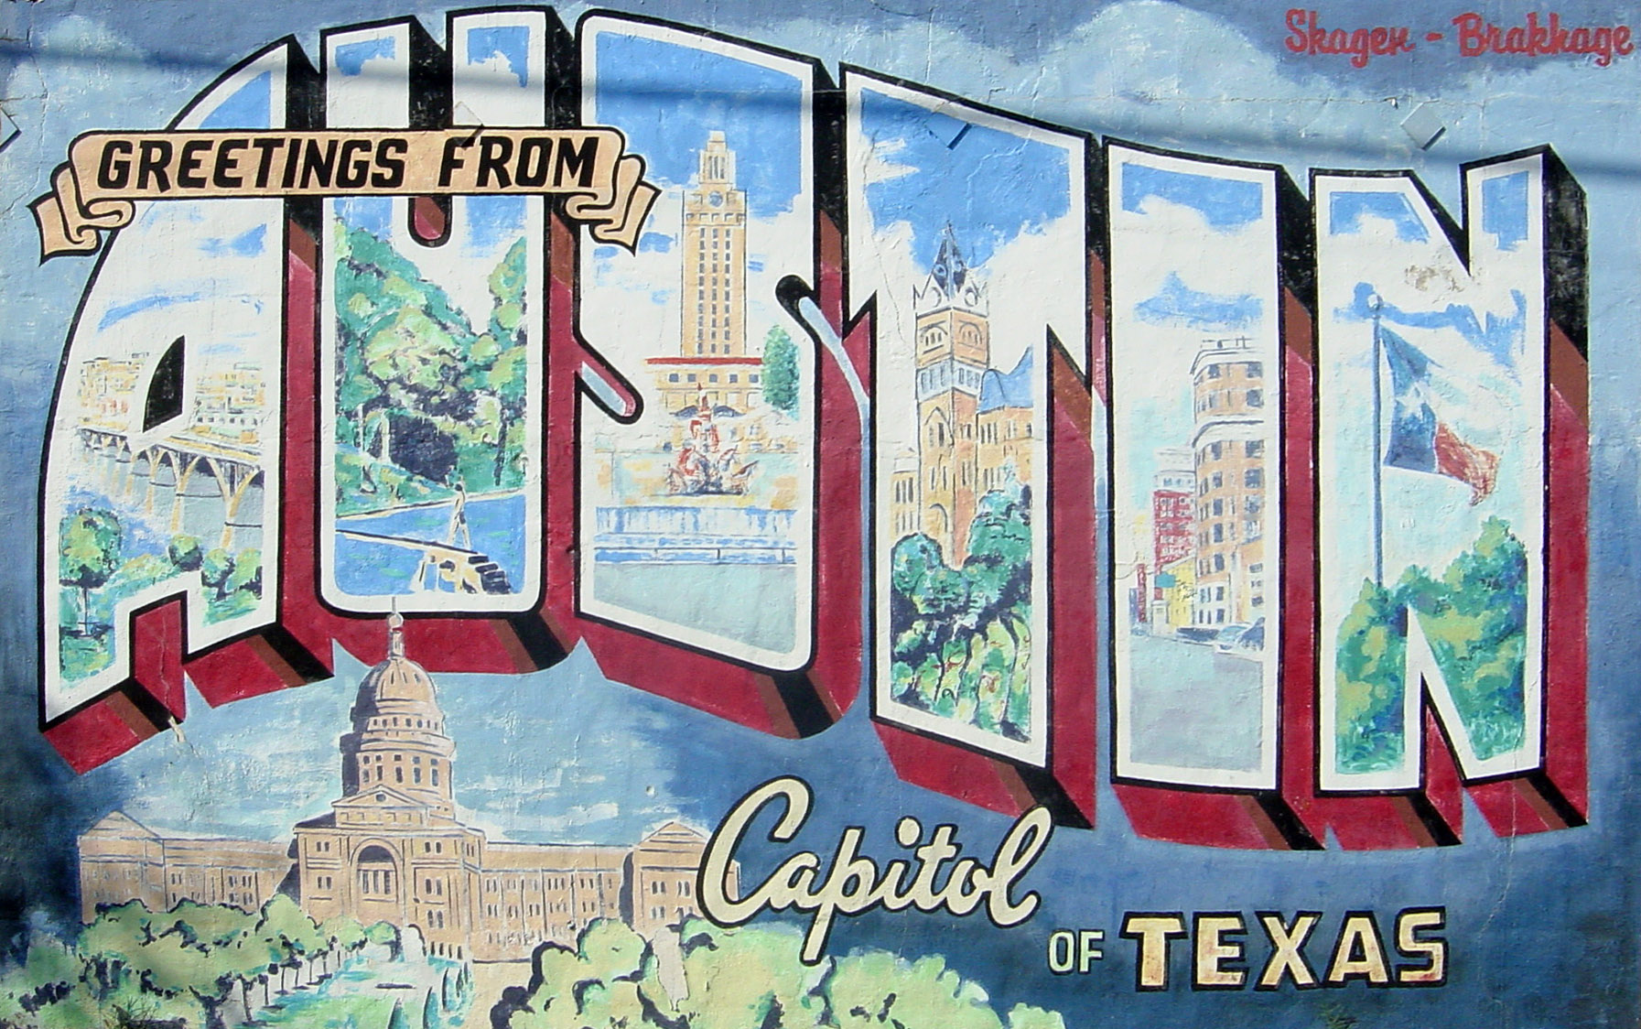Austin Texas is one of the fastest growing cities in the U.S. (Forbes), and as a result, we are a city that needs to focus on our carbon footprint and continue to lead the nation in the fight against climate change. Through the many helpful programs that Austin has such as Keep Austin Beautiful and the Office of Sustainability, we have become a leading city in the fight against climate change and the city council has set a goal to take certain steps until 2020 to significantly reduce greenhouse gas emissions and make Austin the most livable city in the U.S. Some of the plans to reach this goal include making all city facilities carbon neutral and implementing energy efficient building codes (Climate Resolution).

Our group realized how many major changes are occurring in Austin already and decided that we should help to educate people in Austin on how they can help make a difference and reduce their *individual* carbon footprint. We want to help individuals live greener lives and save them money while helping the city of Austin reach its goal.

Easy Ways To Reduce Your Carbon Footprint:

(Step 1) Before you get started, a helpful thing to do is calculate your current individual carbon footprint. Use the EPA’s carbon emissions calculator on their website to get a more clear and accurate idea of where you need to improve the most!

Cut Household Emissions

By simply making a few small changes in your home, you can reduce your carbon footprint and save money. Your home, no matter how large or small, is an energy drain in which electricity and heating are the 2 major generators of emissions (EPA). To reduce your homes impact, you can...

* 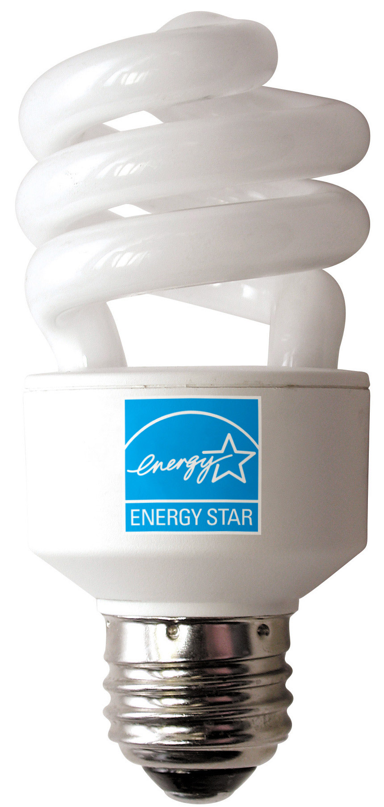 Replace frequently used light fixtures in your home with compact fluorescent light bulbs which use at least 2/3 less energy than standard incandescent ones and last up to 10 times longer. By making this simple change, throughout your house, you will be helping the environment as well as saving about $60 a year on energy bills (Crawford, Benna)!
* When buying new home appliances, search for ENERGY STAR qualified products that help to reduce greenhouse gas emissions (Crawford, Benna).
* Heat and cool smartly: clean air filters regularly, install adequate insulation, and do your part by lowering your winter thermostat and raising it in the summer (EPA).
* To make it easier to heat and cool smartly, install a programmable thermostat, which through the use of pre-programmed settings can save you about $180 a year in energy costs (Energy Star)!

Reduce, Reuse, Recycle

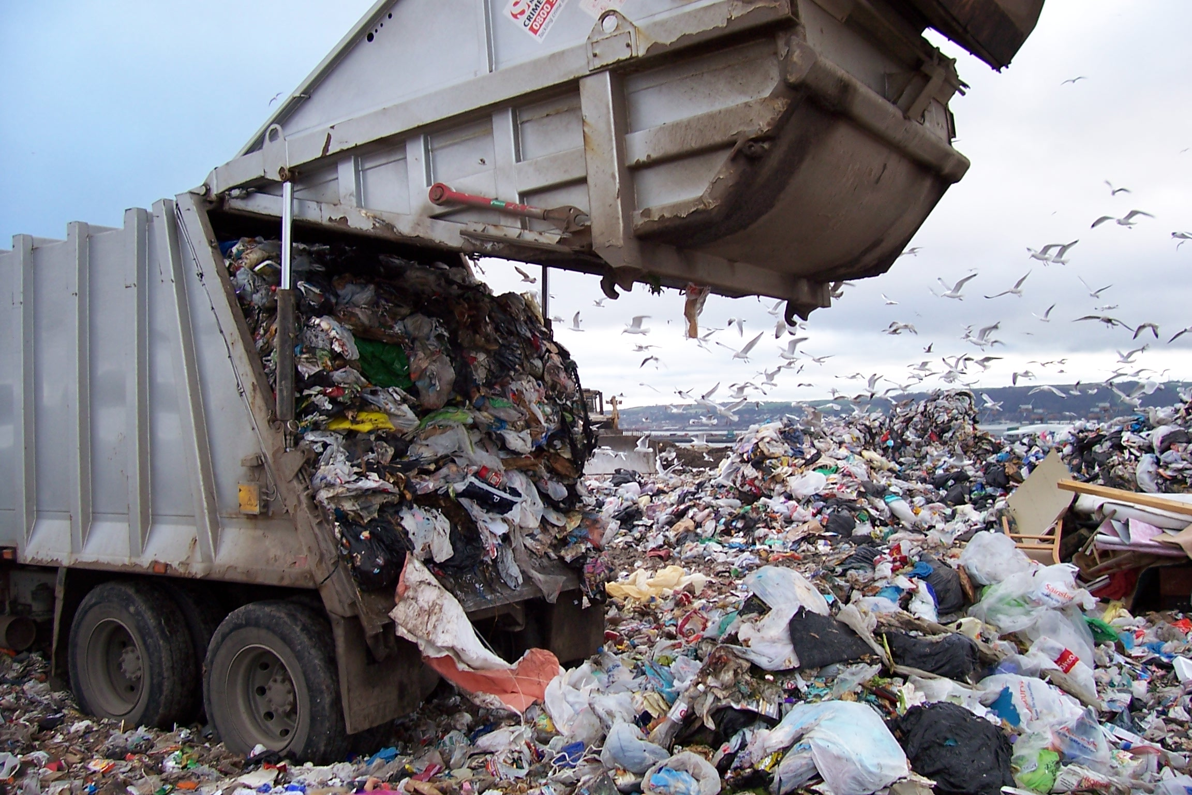Reduce: Waste is the third largest generator of household emissions (EPA). Try to reduce the amount of waste you create and water you use as often as possible. You can reduce water waste by simply…

* Taking shorter showers and less baths.
* Not letting the water run while brushing your teeth.

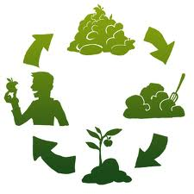Reuse: You can help to reduce the amount of waste you generate through composting. Composting keeps tons of garbage out of landfills and reduces greenhouse gas emissions. So here’s how you do it-

1. Keep a small compost container in the kitchen (available at most hardware and gardening stores) for coffee grounds, eggshells, tea bags, fruits and vegetables, etc.
2. Transfer compost to a dirt covered compost pile
3. In 2 to 6 months, you will end up with perfectly usable compost for your garden (BBC)!

Recycle: In the city of Austin’s residential recycling program, you are able to recycle…

* Paper (Envelopes, newspapers, paper bag, magazines etc.)
* Boxboard and cardboard (shoe boxes, paper towel rolls, boxes etc.)
* Aluminum and metals (aluminum foil –balled 2 in. or larger -, Aluminum baking pans, food/soda cans etc.)
* Glass (Jars and bottles as well as their caps)
* Plastic containers (water, soda, milk detergent and soap bottles, yogurt containers)

And don’t forget to have your recycling bins out by 6:30 A.M. and make sure to set your carts at least 5 feet apart (Residential Recycling)!



Grow Green

Whether you are planting a garden for your whole neighborhood to enjoy, having your own personal garden, or simply growing some flowers in a pot, you are helping the environment and reducing greenhouse gasses. Plants play a major role in helping reduce carbon emissions and add visual appeal as well.

Native central Texas plants that are good for container gardens:

* 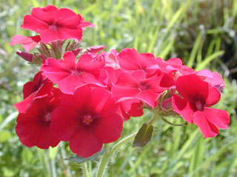Damianita
* Evening rain lily
* Gray golden-aster
* Texas yellowstar
* Blackfoot daisy
* Annual phlox

Drought resistant plants for Texas:

* 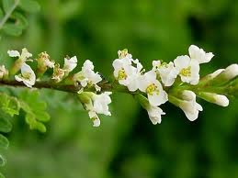American century plant
* Buffalograss (an especially good choice for lawns!)
* Candelilla
* Texas kidneywood
* Red yucca
* Texas lantana

Many more examples for both of the above categories and more can be found on the LBJ Wildflower Center website

Lawns – Not Always Bad:

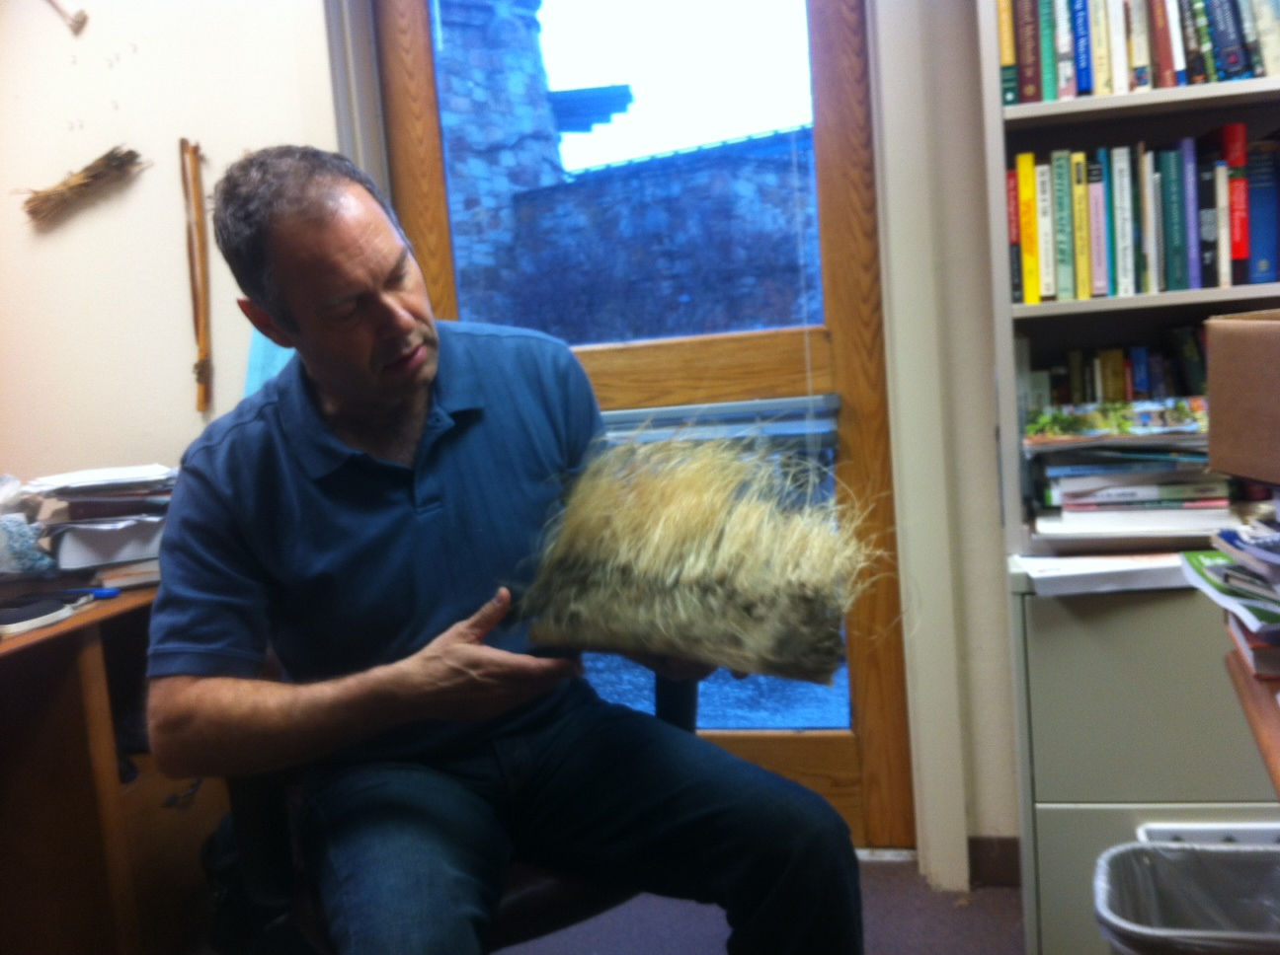In Austin recently, people have begun to see lawns as bad for the environment because they use so much water and gasoline to keep up. The truth is this doesn’t have to be the way for all lawns. According to Mark Simmons – Director of research and consulting at the wildflower center – “lawns have actually been perceived lately as ‘aw they’re so bad’ but that’s actually because they are easy to do wrong, but you can do them right to”. The trick is to use grasses that are native to Austin – so they require little water – and grow slowly – so you don’t need to mow them as often – and next thing you know, you have a lawn whose benefits outweigh the negative aspects.

Eat Green

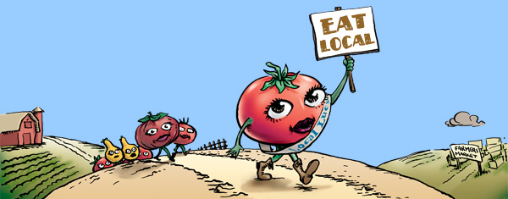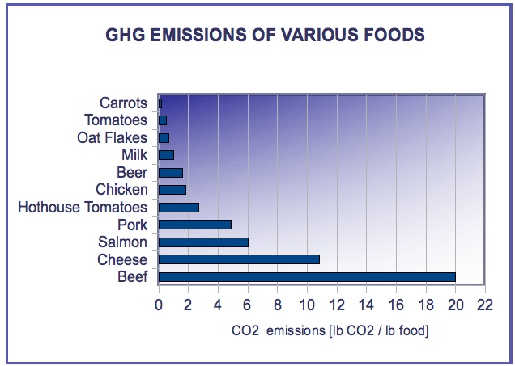What you eat can play a major role in the size of your carbon footprint. A typical grocery basket with 20 items from a supermarket could have over 100,000 ‘food miles’ (BBC)! Food transport is a major contributor to greenhouse gas emissions and global warming. Here are some steps you can take in order to have a ‘low carbon diet’…

* 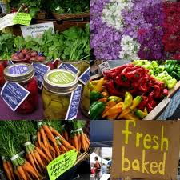Switch to grass-fed over feedlot beef, which racks up the most carbon due to production, processing and transportation (BBC).
* Eat organic foods – smaller impact on the environment.
* Eat locally sourced foods at home and in restaurants, which reduces carbon-intensive shipping and refrigeration and supports small farms.

Drive Green

Burning fossil fuels releases carbon dioxide into the atmosphere and effects climate change. You can help to reduce this amount of fuel and decrease the size of your carbon footprint by…

* 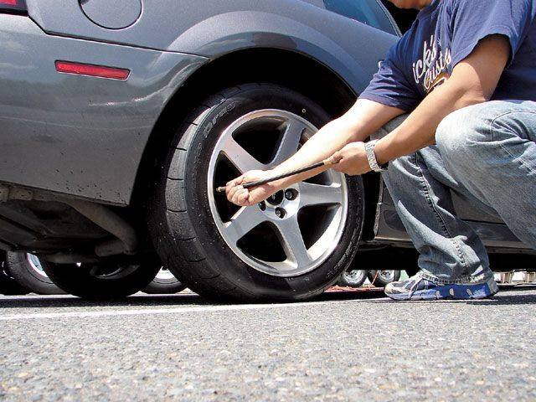Maintaining your vehicle. A well maintained car is more fuel-efficient, has reduced greenhouse gas emissions, and is more reliable and safer.
* Check your tire pressure often. Deflation can reduce your fuel economy up to 3% (EPA), which leads to an increase in emissions of greenhouse gasses.
* Walk, ride a bike or take public transportation instead of making short car trips. If you leave your car at home for just 2 days a week, your greenhouse gas emissions will reduce by an average of 1,600 pounds a year (EPA).
* Use renewable fuels. Fuels such as E85 and biodiesel are renewable fuels that can reduce the greenhouse gas emissions from your car (EPA).



Take Action:

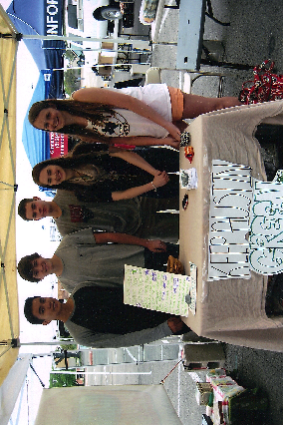To have an even bigger impact, it is import to share this information with others. The only way to ever truly solve the issue of the Earth’s growing carbon footprint is if everyone does his or her part. And for some, the only thing getting in their way is a lack of information.

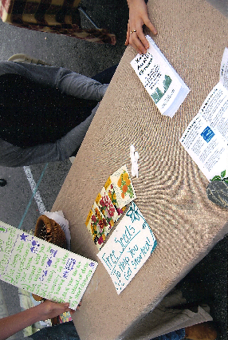My group and I knew this and we knew that the most effective way to make a difference was not by helping just one person reduce their carbon footprint, but it was by informing many people about the issue and making it easy for them to make a difference.

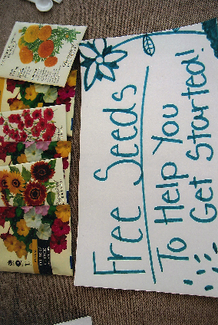To take action we set up a booth at the Barton Creek Farmers market and handed out brochures filled with information on easy ways to reduce your carbon footprint in Austin. Also, to help people get started, we gave out free packages of seeds, which we knew would be a lot less likely to go to waste.

You Can Take Action As Well!

Spreading the word on the importance of reducing the Earth’s carbon footprint is the best way to get people wanting to help and the quickest way for Austin to reach its goal. All it takes is the support of individuals and the knowledge needed to get started.

Convince people who don’t believe this is an issue worth fighting for that it is! And help inform others on how they can play their part in making the city of Austin and the rest of the world a more livable place.

Works Cited

(EPA)

"Basics." *EPA*. Environmental Protection Agency, n.d. Web. 14 Apr. 2013. <http://www.epa.gov/climatechange/basics/>.

(Rebello, Snehal)

Rebello, Snehal. "City's Annual Carbon Emission Twice That of National Average." *Http://www.hindustantimes.com/*. N.p., 24 July 2012. Web. 14 Apr. 2013. <http://www.hindustantimes.com/India-news/Mumbai/City-s-annual-carbon-emission-twice-that-of-national-average/Article1-894569.aspx>.

(Green Cities)

"15 Green Cities." *Grist*. N.p., n.d. Web. 14 Apr. 2013. <http://grist.org/article/cities3/>.

(Forbes)

*Forbes*. Forbes Magazine, n.d. Web. 14 Apr. 2013. <http://www.forbes.com/pictures/mlj45hfdf/1-austin-texas/>

(Climate Resolution)

"Climate Program." *Office of Sustainability*. Austintexas.gov, n.d. Web. 14 Apr. 2013. <http://austintexas.gov/department/austin-climate-protection-program>.

(Crawford, Benna)

Crawford, Benna. "The Carbon Footprint of a Household | National Geographic." *Green Living on National Geographic*. N.p., n.d. Web. 14 Apr. 2013. <http://greenliving.nationalgeographic.com/carbon-footprint-household-2467.html>.

(Energy Star)

"Heat & Cool Efficiently." *: ENERGY STAR*. N.p., n.d. Web. 14 Apr. 2013. <http://www.energystar.gov/index.cfm?c=heat_cool.pr_hvac>.

(BBC)

"BBC Good Food." *20 Ways to Live a Greener Life -*. N.p., n.d. Web. 14 Apr. 2013. <http://www.bbcgoodfood.com/content/wellbeing/features/greener_cook/1/>.

(Residential Recycling)

"Residential Recycling Collection | Austin Resource Recovery | AustinTexas.gov - The Official Website of the City of Austin." *Residential Recycling Collection | Austin Resource Recovery | AustinTexas.gov - The Official Website of the City of Austin*. N.p., n.d. Web. 14 Apr. 2013. <http://austintexas.gov/department/single-stream-recycling>.