Chase Durand
Advocacy Project: Poster
Project Advisor: Webster
8th Period English
Group Members: Shalui Abeles, Maddie Fusco, Morgan O’hanlen, Joseph Griesel

Full-size poster and colored copies:
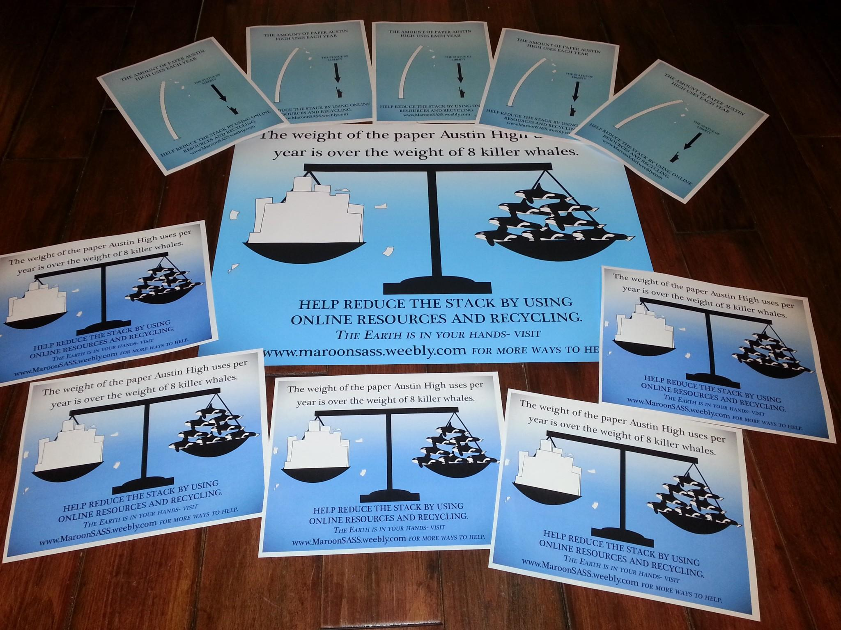
(I printed a full-size version of the design concerning height, but it had a grammatical error that I hadn’t spotted at the time, so it will not be shown. This mistake was corrected for all other copies.)

Additional black and white copies:
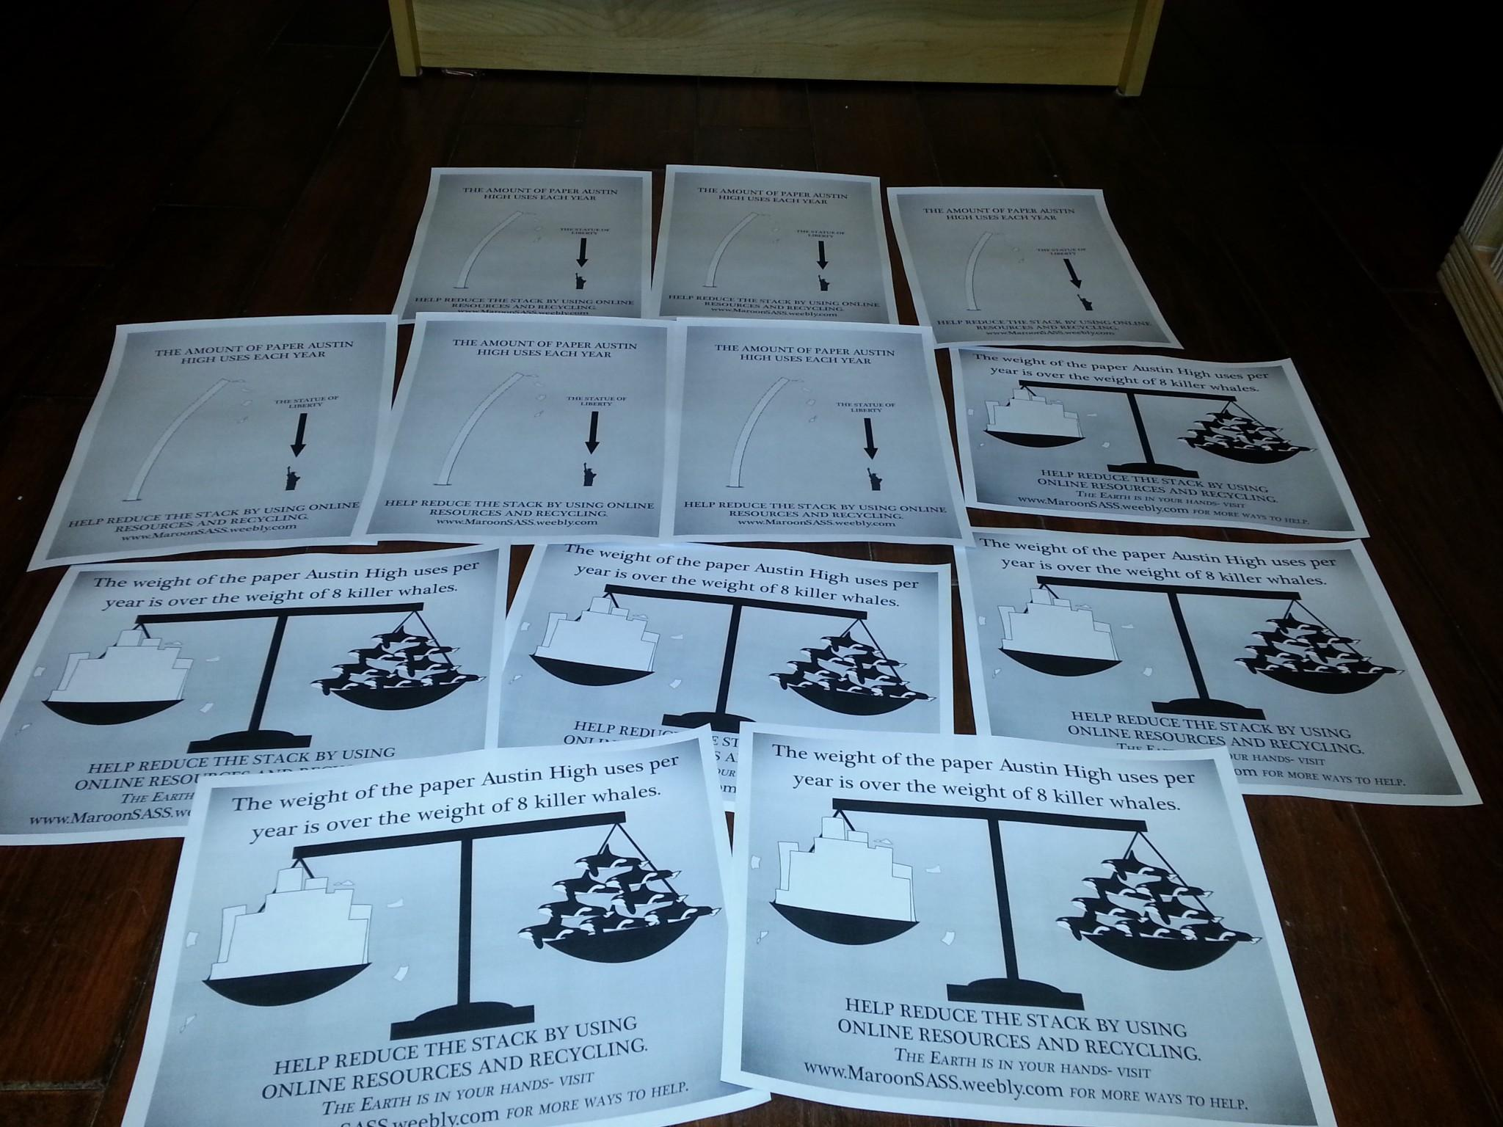

Advocacy Sources

Fairchild, Renee. Personal interview. 8 Mar. 2013.
(Note- This discussion was not one of the interviews transcribed and wasn’t even planned; we simply went to her office to ask her about some statistics.) Ms. Fairchild informed us about the exact amount of paper used yearly at Austin High School.

Sessions, Jim. Personal interview. 21 Mar. 2013.
Mr. Sessions told our group which type of paper AISD uses. (The paper type was later confirmed myself when we examined that paper in the copy rooms).

"How Tall Is the Statue of Liberty?" How Tall Is the Statue of Liberty? N.p., n.d. Web. 11 Apr. 2013.
This site told us how tall the Statue of Liberty is.

"Killer Whale (Orca)." National Geographic. N.p., n.d. Web. 11 Apr. 2013.
This website was used to find the weight of a killer whale, which was to be compared with the weight of paper that Austin High School uses yearly.

(The outline of the Statue of Liberty is a modification of the original found here: http://wirednewyork.com/landmarks/liberty/ I am unable to find enough information about it to create a proper citation.)

(The killer whale graphic was traced off of a model killer whale that an image of can be found here: http://www.marinebio.net/marinescience/05nekton/KWbodyform.htm I am unable to find enough information about it to create a proper citation.)

